# 

# ***Project Proposal***

[Hotel Management System]

***[Project Group Members]***

1. ***[ 12413 Safiullah Rehmani]***
2. ***[11869] Syed Saifuddin]***
3. ***[12452 Shaheer Shakeel]***
4. ***[12113 Shahmeer Khan]***

# ***Introduction to project:-***

**Hotel Management System**  is a type of property management system that facilitates the management of hotel operations and functions; main operations such as front office, sales, planning, and accounting. The most frequent course of action; Visitor/Client or Guest comes in hotel and books his/her room for some duration. Visitor will provide his own personal details and will get room number according to availability. Yes, there will be different charges for varying category of rooms, according to facilities. After payment visitor will checkout from the hotel.

##### General Hotel Management Software aims to automate functions such as:

Customers/Guest Info:

1. Guest bookings
2. Guest details

Staff/Crew:

1. Staff Members
2. Salaries
3. Availability

Reservations/ Stays/ Reception:

1. Telephony
2. Room Availability
3. Room Fare

Accounts Office/General Maintenance:

1. Accounts receivable
2. Sales and marketing
3. Booking Info.
4. Cash Register
5. Banquets

Surveillance and Security:

1. Event Management
2. And many more features

Others:

1. Point of sale

The sub-categories may vary, but the 5 main tables are the core of Hotel Management System.

##### Modules of many Hotel Software are:

1. Reservations includes pre-booking, and booking functions
2. Profiles for classifying what guest, privileges , and memberships
3. Groups and blocks for large groups of guests with different privileges
4. Rate and inventory control monitoring for rooms, amenities and materials
5. Administration assigns the access control for each hotel department , and other staffs
6. Reporting displays custom reports for various outputs in the automated hotel operations
7. Database Administrator filing periodic report of all relevant clauses of action
8. Staff and Hotel Crew members basic information, their paid leaves and unpaid leaves, all accounting to their salary to be delivered to their accounts.
9. Also keeping a track of the performance of employees, so as to be useful in terms of promotion etc

# ***Feasibility Study:-***

# A feasibility study investigates your hotel, resort, or hostel proposal to see if it is feasible as a sustainable and profitable business model. It does so by considering its viability relating to market, location, costs and financing. Basic mistakes like Data Repetition are checked.

# ***Purpose of the Website:***

The main purpose of hotel management is to ensure a constant influx of visitors and guests to the hotel throughout the year, showcase the wide variety of services and USPs and how it benefits the visiting guests through marketing initiatives. Moreover, it also involves driving qualitative leads through innovative business strategies.

* Hotel administration
* Finance
* Hospitality
* Catering management
* Housekeeping
* Marketing and
* Accounts

Below is a conceptual ER diagram for the Model website.

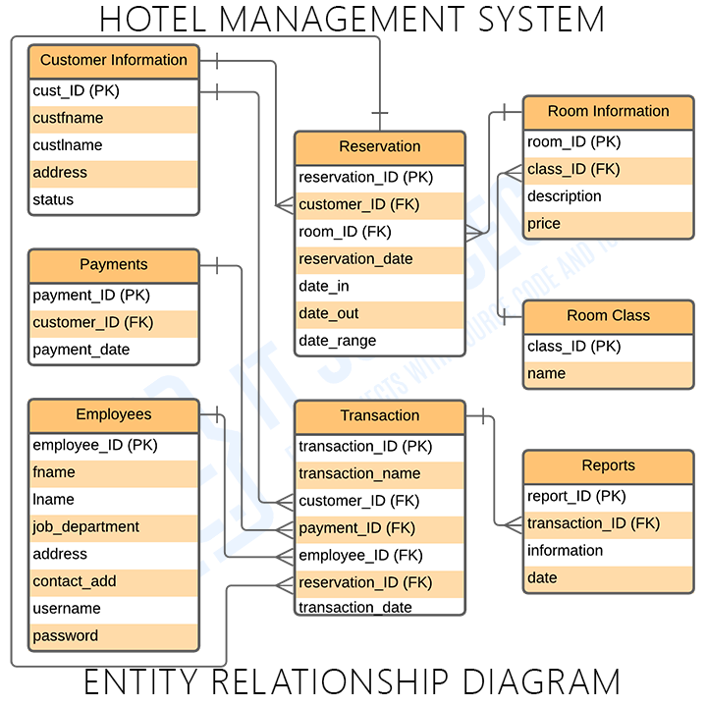

*Main Features*

**Hotel Management**

Hotel Management is the main feature of the system wherein the hotel information were managed included its basic details, accommodation, employees and services offered.

**User Management**

This feature is in charge of adding, updating and deleting of the user’s information. Example of users were the admin or the owner, service crews or the employees and the customer. Each of them will have their basic data stored in the Customers/Guests table and it’s associated tables.

**Managing Reports**

The hotel admin is the one who can have access to all the transaction made in the system. These transaction were made of customers’ inquiries, reservation, services rendered and many more. The they will be secured in the system’s database for the purpose of doing reports and other important activities.

**Customer Reservation**

Customer reservation requires the customer’s basic information such as name, contact address, etc. to enable hotel admins to trace their transaction whenever they avail services from the Hotel. Now these customer’s basic information and reservation should be stored in the database to calculate their payment and other purposes, such as to keep a storage proof in case one of their customers get stuck in some legal issues or etc.

**Transaction and Reports Management**

This feature will store the transactions made by the customers including their information and the reports of every transactions made by the hotel personnel and customers.

The below diagram illustrates how the MVC website will co-ordinate with the Database to fulfill a course of action.

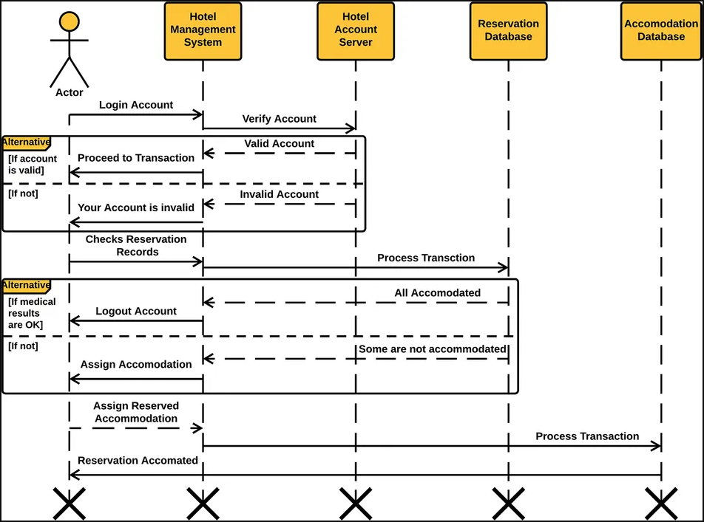

The following diagram shows the frontend working, Excluding Database details.

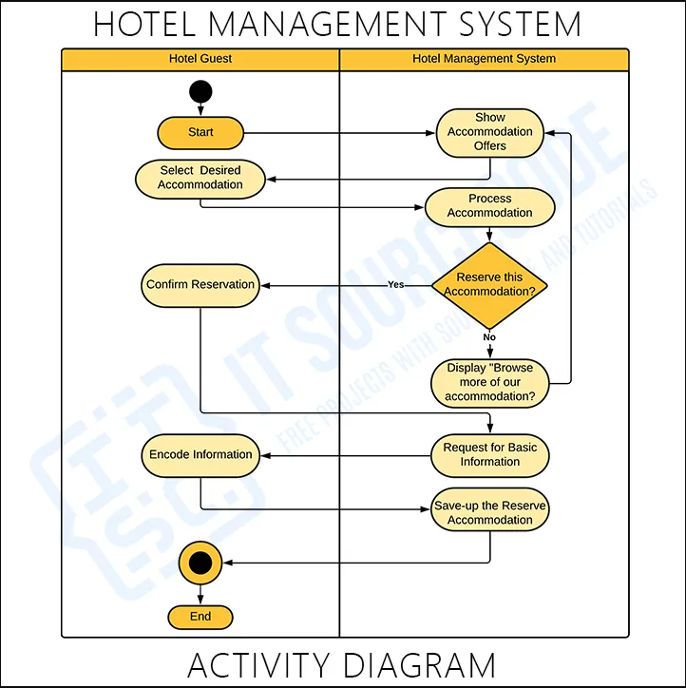

# ***Reference of Existing Website:-***

Regent Plaza

https://www.rphcc.com/